DRL 6
All the questions are based on India and Australia tables
In the TrID column the first 3 characters are country code followed by _, then the next 3 digits are for the transaction serial number followed by _ and finally last two characters are for counter number, i.e. through which counter the transaction has happened.
- Display all columns along with new column Discounted_Amount as 5% on the amount for those transactions having quantity sold is above 3 for both the countries.
- Display product name wise number of products sold in each country along with a sub total of each country as shown next:

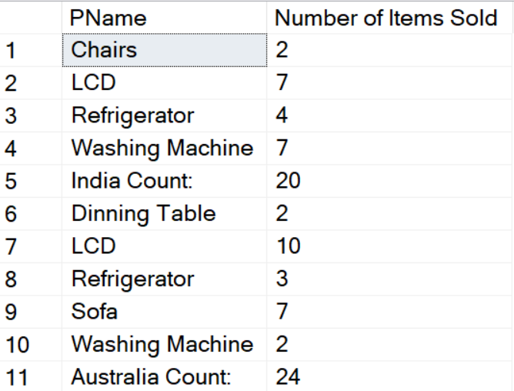

- Display the following output:
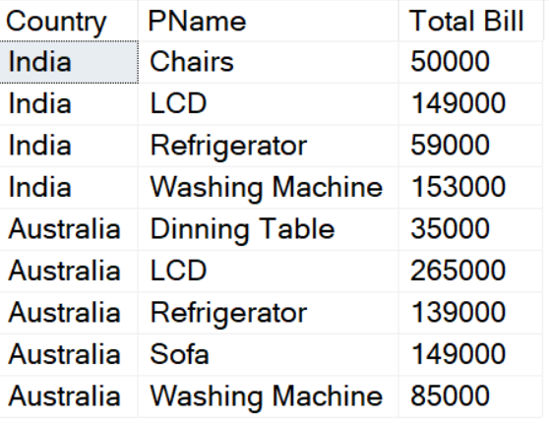
The Total bill will be summation of amounts as per products within each country.

- Display week days transaction details for both the countries excluding the transactions done on 1-Jan-2019.
- Display all the transactions of India as well as Australia sorted as per date of purchase oldest to latest. Also display grand total of amounts country wise as the last 2 rows in the output.
- Display all the transaction details done in counter 3 for both the countries.

